

Web-Based Interfaced Design

Lab Report CSF3133 (K4)

Name: Muhammad Syukran Bin Mohd Zakri
Number Matrics: S75572
Lecturer’s Name: Prof. Madya Ts. Dr. Wan Nural Jawahir binti Wan Yussof
Ms. Wan Fatin Fatihah binti Yahya
Date:12/11/2025

Activity 4.2
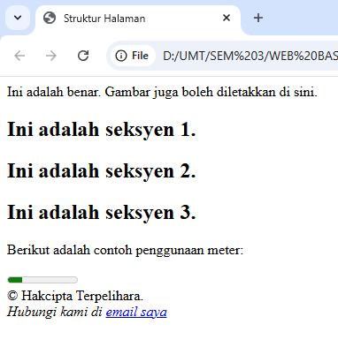
Activity 4.3
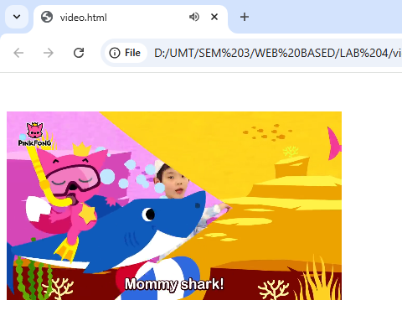

Activity 4.4
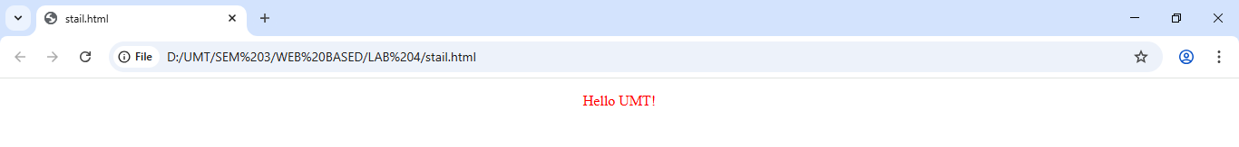
Activity 4.5
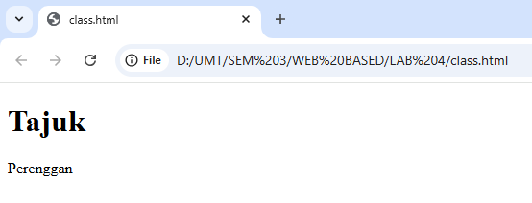
Activity 4.6
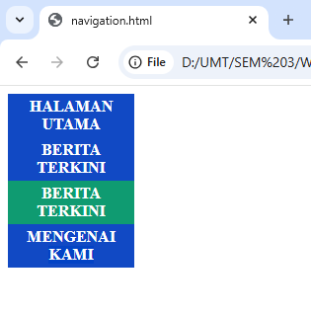

Activity 4.7
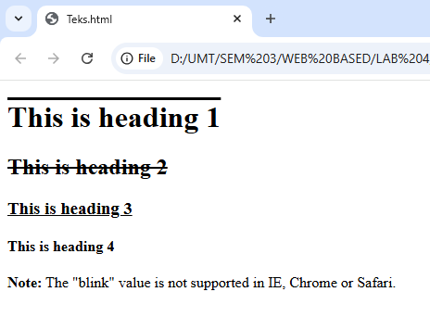
Activity 4.8
Unvisited link
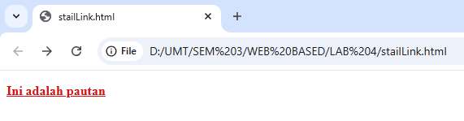
Visited link
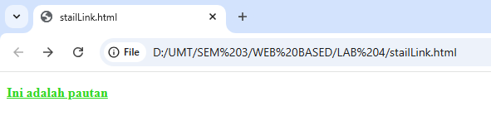

Mouse over link
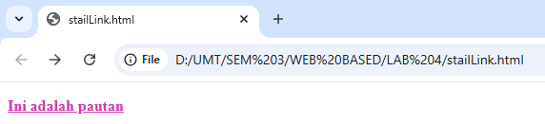
Selected link
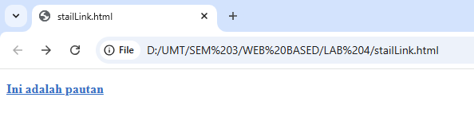
Lab exercise
Code:
<!DOCTYPE html>
<html lang="en">
<head>
<meta charset="UTF-8">
<meta name="viewport" content="width=device-width, initial-scale=1.0">
<title>Lab 4 Webpage</title>
<!-- External CSS -->
<link rel="stylesheet" href="style.css">
<!-- Internal CSS -->
<style>
header {
background-color: #101d61;
color: rgb(221, 82, 82);
padding: 20px;
text-align: center;
}
nav ul {
list-style-type: none;
background-color: #a525d8;
overflow: hidden;
margin: 0;
padding: 0;
}
nav li {
float: right;
}
nav li a {
display: block;
color: white;
text-align: center;
padding: 14px 16px;
text-decoration: none;
}
nav li a:hover {
background-color: #111;
}
section, article {
margin: 20px;
}
video {
width: 100%;
border-radius: 8px;
}

/* main content */
main {
display: flex;
justify-content: space-between;
align-items: flex-start;
gap: 40px;
margin: 20px;
}

/* Home + About */
.left-content {
flex: 2;
}

/* media section */
#media {
flex: 1;
background-color: #f2f2f2;
padding: 20px;
border-radius: 8px;
}
/* StailLink*/
a:link{color: rgb(214, 19, 19);}/* unvisited link*/
a:visited{color: rgb(47, 216, 31);}/* visited link*/
a:hover{color: rgb(216, 51, 180);}/* mouse over link*/
a:active{color: rgb(55, 112, 197);}/* selected link*/
</style>
</head>
<body>
<header>
<h1>Welcome to Lab 4 Webpage</h1>
<h2>Food Webpage</h2>
</header>

<nav>
<ul>
<li><a href="#contact">Contact Us</a></li>
<li><a href="#about">About</a></li>
<li><a href="#media">Media</a></li>
<li><a href="#home">Home</a></li>
</ul>
</nav>
<main>
<div class="left-content">
<section id="home">
<article>
<h2>Home</h2>
<h3>Introducing some food recipes from the entire world!</h3>
<p>this is the source you can refer:</p>
<p><b><a href="https://resepichenom.com/" target="_self">
CLick here for external website.</a></b></p>
</article>
</section>

<section id="about">
<article>
<h2>About</h2>
<form action="">
Name: <input type="text" name="nama"
placeholder="Masukkan nama anda di sini." autofocus autocomplete>
<br><br>
Email: <input type="email" name="user email"
placeholder="Tulis email anda">
<br><br>
<label for="gender">Gender: </label><br>
<input type="radio" id="male" name="gender" value="male">
<label for="male">Male</label><br>
<input type="radio" id="female" name="gender" value="female">
<label for="female">Female</label><br><br>
Favorite Hobbies: <input type="text" name="user hobbies"
placeholder="Insert your hobby">
<br><br>
<input type="submit" name="submit">
</form>
</article>
</section>
</div>

<!-- Video section-->
<section id="media">
<article>
<h2>Malaysian Popular Cuisine</h2>
<p>Making of Nasi Lemak:</p>
<video controls>
<source src="Nasi Lemak.mp4" type="video/mp4">
Your browser does not support the video tag.
</video>
</article>
</section>
</main>

<footer>
<p>&copy; 2025 My Lab 4 Webpage. All Rights Reserved.</p>
</footer>

</body>
</html>

Output:
